Predicting Online Shopper Purchase Intention Using Machine Learning Classification Techniques

Abstract— There is huge amount of browsing data generated by e-commerce platform which can be used to analyse online customer behaviour and predict their buying intention. However, many visitors browse online shopping websites without making a purchase, which makes it hard for businesses to identify potential buyers and improve conversion strategies. The aim of this study is to predict whether an online shopping session leads to a purchase or not using the Online Shoppers Purchasing Intention Dataset from the UCI Machine Learning Repository.
The dataset was cleaned by removing duplicate records, leaving 12,205 online shopping sessions. Data preprocessing, exploratory data analysis, model training and model evaluation were done using Python. Four machine learning classification models were created and evaluated: Logistic Regression, Decision Tree, random Forest and XGBoost. The performance of the models was evaluated using accuracy, precision, recall, F1-score, confusion matrix and AUC-ROC. Power BI was also used to develop dashboard visuals to support interpretation of the findings.
The results indicate XGBoost had the highest accuracy of 88.73%, the highest F1-score of 0.673 and the highest AUC-ROC score of 0.9252, while Random Forest had the highest AUC-ROC score of 0.9316. Feature importance analysis showed that Page Values was the strongest predictor of purchase intention, followed by ExitRates and ProductRelated_Duration. These findings suggest that page engagement behavior is more influential than demographic or source-based attributes in predicting online purchases. The study demonstrates how machine learning and web analytics can be used to inform e-commerce decisions, targeting customers, and optimizing conversions.
Keywords-Web Analytics, Online Shopper Behavior, Purchase Intention, Machine Learning, Classification

Introduction
The rapid growth of e-commerce has changed the way businesses interact with customers. Online shopping platforms gather large amounts of browsing data, such as the number of pages visited, the time spent on product pages, the type of visitor, bounce rate, exit rate, and traffic source. Previous studies have shown that these data can be used to gain insight into customer behaviour and patterns that can impact on customer buying decisions [1], [2], [3].
In web analytics, understanding whether a visitor is likely to complete a purchase is important because many users browse websites without buying anything. Identifying factors related to purchase intention can help businesses improve website design, marketing strategies and customer engagement. Machine learning provides a useful approach for analyzing historical browsing data and predicting future customer behavior [4], [9], [10].
The aim of this project is to predict the intention of an online shopper to purchase using the Online Shoppers Purchasing Intention Dataset available from the UCI Machine Learning Repository. The target variable of the dataset is Revenue, which indicates whether an online browsing session resulted in a purchase. This project is considered a binary classification problem because the outcome can be either purchase or no purchase [1], [2], [8].
Several machine-learning classification models will be applied and compared to determine which model performs best in predicting purchase intention. The accuracy, precision, recall, F1-score, confusion matrix and AUC-ROC will be used to evaluate the performance of the models. These metrics are important because the dataset is imbalanced, and previous studies have shown that relying only on accuracy may be insufficient for online purchase-intention prediction [2]-[4], [6]. In addition, Power BI will be used to develop a dashboard to visually present important patterns and findings from the dataset.

Problem Statement
Many visitors browse e-commerce websites without buying anything. This creates a challenge for online businesses because they may not fully understand which browsing behaviors are linked to successful purchases. Without proper analysis, businesses may struggle to identify potential buyers, improve conversion rates and make effective marketing decisions.
Although web browsing data contains useful information, it is difficult to interpret manually due to the number of variables involved. Therefore, machine-learning classification techniques can be applied to identify patterns in online shopper behavior and predict whether a browsing session is likely to result in a purchase.

Research Objectives
The objectives of this study are:
- To analyze the browsing behavior of online shoppers using the selected dataset.
- To develop machine-learning classification models to predict online purchase intention.
- To compare the performance of selected classification models using accuracy, precision, recall, F1-score, confusion matrix and AUC-ROC.
- To identify the features that have the greatest influence on online purchase intention.
- To present the findings through an interactive Power BI dashboard.

Research Questions
This study aims to answer the following research questions:
- Which browsing behavior features are associated with online purchase intentions?
- Which machine-learning classification model performs best in predicting whether an online session results in a purchase?
- How can the findings support e-commerce businesses in improving customer targeting and conversion strategies?

Scope of Study
This study focuses on the Online Shoppers Purchasing Intention Dataset obtained from the UCI Machine Learning Repository. The data includes details about online shopping sessions such as admin page visits, informational page visits, product related page visits, page duration, bounce rate, exit rate, page value, month, visitor type, traffic type, weekend status and revenue outcome.
The target variable used in this study is Revenue, which shows whether a browsing session resulted in a purchase. Selected machine-learning models will be used for binary classification. Data cleaning, exploratory data analysis, model training and model evaluation will be performed using Python. Power BI will be used to create dashboard visuals that support the interpretation of the findings.
This study does not include real-time customer tracking, customer personal information, financial transaction details or data from other e-commerce websites.

Significance of Study
This study is significant because it shows how e-commerce browsing data can be converted into useful decision-making insights. The findings may help e-commerce marketing teams and conversion-rate optimisation analysts identify visitor behaviours that are more likely to lead to purchases. This can support better targeting, website improvement and customer engagement strategies.
From an academic perspective, this study demonstrates the practical use of machine-learning classification in web analytics. By comparing several models and evaluating them using multiple performance metrics, the study provides a clearer understanding of how predictive analytics can be applied to online shopper behaviour.

Literature Review

Review of Articles
This literature review section examines prior research studies on applying machine-learning classification to predict online shopper purchase intention and e-commerce conversion behaviour. This particular area has been an emerging topic and growing demand for online retailers, as they increasingly need to distinguish browsing sessions likely to convert from those that are not. The purpose of this investigation is to enable more targeted marketing and resource allocation. There is a total of ten studies reviewed in this paper. Some studies used the same UCI Online Shoppers Purchasing Intention dataset and other studies included comparable e-commerce behavioural datasets. Diverse set of dataset studies was intentionally picked to provide a broader view of the methodological landscape. Articles were sourced from Google Scholar, ACM Digital Library, ScienceDirect, IEEE Xplore, and SpringerLink, prioritizing peer-reviewed journal articles and conference papers from 2019 onward. However, one exception was made for Niu et al. [10] article, included for its distinct search-behaviour prediction angle. All ten articles were selected for their relevant research ranging from classical machine-learning baselines, boosting and ensemble methods, class-imbalance handling techniques to interpretability-focused approaches.

Real-Time Purchase-Intent and Site-Abandonment Prediction
Sakar et al. [1] proposed a real-time system combining two prediction tasks, purchase-intent prediction and site-abandonment detection. The purchase intent module was trained on Random Forest (RF), Support Vector Machine (SVM), and Multilayer Perceptron (MLP) classifiers, all trained on the UCI dataset’s 12,330 sessions, while a Long Short-Term Memory (LSTM) model handled abandonment prediction with raw clickstream sequences. Among the module classifiers in this study, MLP produced the highest accuracy and F1-score. Prediction results were significantly improved further when clickstream data was combined with session-level features. One drawback noted by the authors is that the LSTM module adds real-time computational overhead during real-time tracking.

Gradient Boosting for Imbalance-Sensitive Prediction
Models trained purely to maximize accuracy tends to underperform on imbalance-sensitive metrics. This tendency is a gap Abdullah-Al-Tanvir et al. addressed in [2]. This study used chi-square feature selection applied with Synthetic Minority Oversampling Technique (SMOTE) to the same UCI dataset. They found that XGBoost delivered the strongest result of auROC (0.937) and auPR (0.754). Decision Tree inches a close second with 90.54% accuracy. However, the study stopped short of testing deep-learning architectures or evaluating real-time deployment scenarios.

Ensemble Learning Comparison with SMOTE
Four ensemble approaches were compared in Adhikari’s [3] study. The ensemble methods include Random Forest, Gradient Boosting, XGBoost, LightGBM combined with SMOTE and parameter tuning on the same UCI dataset. For the results, they found that XGBoost delivered the strongest prediction of 93.54% accuracy. This study however leans too heavily on accuracy as its primary metric, offering limited insight into precision and recall, despite the class imbalance in the data.

Oversampling-Based Ensemble Reconstruction
Arora et al. [4] compared PART, Decision Tree, Naive Bayes, and Logistic Regression before layering bagging, max-voting ensembles, and boosting to investigate whether SMOTE-based reconstruction could make classifiers more reliable. They found that after reconstruction, every base classifier improved performance. Best result overall was bagging with PART which reached 92.62% accuracy. The study’s limitation is that only four relatively simple base learners were tested.

Behavioural Correlation Analysis of Purchase Intent
Shi [5] examined which behavioural factors influence purchase decisions using descriptive statistics alongside Logistic Regression, Decision Tree, and Random Forest on the same dataset. Time on site and PageValues correlated positively; bounce and exit rates correlated negatively. Random Forest performed strongest at 87.5% testing accuracy. No imbalance-correction technique was applied despite the dataset's 84.5%/15.5% skew.

Bootstrapping for Class Imbalance Correction
Irsheid et al. [6] tested bootstrapping resampling against standard splitting across RF, Decision Tree, and Logistic Regression Classifiers. Tree-based models showed clear improvement — RF from 89.5% to 93.6%, Decision Tree from 86.3% to 89.6% — while Logistic Regression barely moved. This suggests bootstrapping's value is concentrated in models that capture non-linear variance.

Simplified Real-Time Ensemble Prediction
Baati and Mohsil [7] extended the real-time problem posed by Sakar et al. by asking if a simpler ensemble could match the performance of the deep-learning module without the overhead. RF, which is far more accurate than Naïve Bayes and has a higher F1-score, confirms that tree ensembles are able to capture the relevant signal without a recurrent network - even if it is still on static data, not live traffic.

Comparison of Classic Classifiers on the UCI Dataset
Muda, Iswari, and Ahsan [8] took the opposite approach and asked the question if classic interpretable classifiers can still compete. Logistic Regression, Decision Tree and Random Forest with oversampling are compared, putting Logistic Regression as a valid baseline model along with tree methods as in the comparison of four models in this project. The main limitation is that we evaluated on only one static dataset.

Explainable Machine Learning for Conversion Prediction
Bastos and Bernardes [9] pointed out another gap: most studies on purchase prediction provide accuracy but do not explain why a model predicts what it predicts. Using telecom session data and SHAP/ALE plots, revealed that customer activity features were the most reliable predictors. This corroborates the feature-importance analysis of this project, but findings may not generalize beyond telecom.

Search-Behaviour-Based Conversion Prediction
Niu, Li, and Yu [10] narrowed the scope further, asking whether on-site search behaviour alone — rather than general browsing data — could predict conversion. Using real search-log data from Walmart.com, they engineered features like click entropy and dwell time, comparing Random Forest against Logistic Regression. RF reached ~76% accuracy, with dwell time and click entropy as the strongest predictors, though accuracy is notably lower than the tree-based results elsewhere in this review.

Literature Comparison Table

TABLE I. Literature Comparison Table
Reference | Title | Problem Statement | Technique | Findings | Limitations
Sakar et al. [1] (2019) | Real-time prediction of online shoppers' purchasing intention using MLP and LSTM RNNs | Predict purchase intent and site-abandonment likelihood in real time | RF, SVM, MLP + LSTM-RNN, with oversampling/feature selection | MLP outperformed RF and SVM in accuracy and F1-score; combining clickstream + session features improved results over either alone | Requires continuous real-time clickstream tracking, adding computational overhead
Abdullah-Al-Tanvir et al. [2] (2023) | A gradient boosting classifier for purchase intention prediction of online shoppers | Improve prediction under class imbalance beyond accuracy-only metrics | SVM, RF, MLP, DT, XGBoost + chi-square feature selection + SMOTE | XGBoost best: auROC 0.937, auPR 0.754; XGBoost/DT accuracy 90.65%/90.54% | No deep learning tested; real-time deployment not addressed
Adhikari [3] (2023) | Online Shoppers' Purchase Intention using Ensemble Learning Approach | Predict purchase completion from shopper history | EDA → RF, Gradient Boosting, XGBoost, LightGBM + SMOTE + hyperparameter tuning | XGBoost 89.97% (raw) → RF 93% (SMOTE) → XGBoost 93.54% (SMOTE+tuning, best overall) | Leans heavily on accuracy; limited precision/recall discussion
Arora et al. [4] (2024) | Ensemble Learning for Enhanced Prediction of Online Shoppers' Intention on Oversampling-Based Reconstructed Data | Improve prediction reliability on highly imbalanced data via reconstruction | PART, DT, NB, LR compared pre/post SMOTE; bagging/boosting/max-voting ensembles layered on top | Best accuracy 92.62% (bagging+PART); best precision/recall 0.923 (max-voting: DT+PART+LR) | Only 4 simple base learners; no boosting methods (XGBoost/LightGBM) tested
Shi [5] (2021) | The Application of Machine Learning in Online Purchasing Intention Prediction | Identify which behavioral factors influence purchase decisions | Descriptive correlation analysis + LR, DT, RF | RF best: 89.5% train / 87.5% test accuracy; PageValues/time positively correlated, BounceRate/ExitRate negatively | Only 3 simple models; no imbalance-correction technique applied
Irsheid et al. [6] (2025) | Predicting User Purchase Intention in Web Analytics Using Machine Learning with Bootstrapping | Handle class imbalance to improve prediction performance | Bootstrapping + standard split; RF, DT, LR compared with/without bootstrapping | RF 89.5%→93.6%, DT 86.3%→89.6% improved; LR flat (88.2%→88.01%) | Only three classifiers tested, no study of bootstrapping with XGBoost/LightGBM
Baati and Mohsil [7] (2020) | Real-Time Prediction of Online Shoppers' Purchasing Intention Using Random Forest | Test whether ensemble methods can match deep learning for real-time intent prediction | Naïve Bayes, Random Forest on session/visitor data | Random Forest gave significantly higher accuracy and F1-score than compared methods | Static dataset, not live traffic; 'real-time' claim is simulated
Muda, Iswari and Ahsan [8] (2020) | Prediction of Online Shopper's Purchasing Intention Using Binary Logistic Regression, Decision Tree, and Random Forest | Compare classic interpretable classifiers as an alternative to black-box models | Logistic Regression, Decision Tree, Random Forest, with oversampling/feature selection | Establishes Logistic Regression as a viable, interpretable baseline alongside tree-based methods | Single static dataset; linear LR may underfit non-linear behaviour patterns
Bastos and Bernardes [9] (2024) | Understanding Online Purchases with Explainable Machine Learning | Recover interpretability from black-box conversion-prediction models | Logistic Regression vs. Gradient Boosting Machine + SHAP/ALE analysis | Customer activity features most predictive of conversion; significant non-linear relationships found | Single-industry (telecom) dataset; feature ranking may not transfer to retail
Niu, Li and Yu [10] (2017) | Predictive Analytics of E-Commerce Search Behavior for Conversion | Predict conversion specifically from on-site search behaviour | Random Forest, Logistic Regression on engineered search-log features (click entropy, position, dwell time) | RF ~76% accuracy; dwell time, user type, click entropy/position most influential | Narrow focus on search only; lower accuracy than tree/boosting studies using richer features
This Study | Predicting Online Shopper Purchase Intention Using Machine Learning Classification Techniques | Online retailers struggle to distinguish which browsing sessions are likely to convert. Thus, it is difficult to prioritize marketing and UX resources without a reliable predictive model. | Logistic Regression, Decision Tree, Random Forest, and XGBoost are trained on the same UCI Online Shoppers dataset (12,205 sessions after cleaning), with class-weighted training to address the 84.4%/15.6% imbalance. | XGBoost achieved the highest accuracy (88.73%) and F1-score (0.673), while Random Forest achieved the highest AUC-ROC (0.9316). PageValues showed as the most influential feature, consistent with several reviewed studies. | Categorical variables were retained as integer codes rather than one-hot encoded, which may imply unintended ordinal relationships. Besides, results are based on a single train/test split without k-fold cross-validation.

Synthesis Paragraph
Across the ten reviewed articles, three consistent trends appear throughout the research, alongside a notable difference in the datasets used. Firstly, tree-based and ensemble methods, with one notable exception, generally outperform simpler linear models. In [6] and [7], Random Forest outperforms the other classifiers. Additionally, XGBoost also posts the strongest results in both [2] and [3], while Decision Tree comes at a close second in [2]. However, this rule is not completely universal as an exception occurred in [1] where MLP (a deep-learning model) outperforms both RF and SVM, showing that sequence-aware deep models can also compete on this task. Second notable common theme is in order to correct the class imbalance, almost all studies including [1] - [4] and [6] apply oversampling, SMOTE, or bootstrapping. These studies corrected the same ~85/15 skew present in this project’s dataset except [5] which omits any imbalance-correction despite acknowledging same skew in its own data. Finally, there is a growing shift toward interpretability and feature importance instead of just pure accuracy. [9] uses SHAP values and Accumulated Local Effects (ALE) plots to explain a black-box model without sacrificing performance. [5] uses descriptive correlation analysis and [10] identifies behavioural signals like click position and dwell time as strongest predictors of conversion. These three findings show a common conclusion that engagement-style behavioural signals matter more than demographic types. Methodologically, eight of the ten reviewed studies [1] - [8] use the same UCI dataset; [9], however, uses telecom session data while [10] uses real Walmart.com search-log data.

Research Gaps and Summary
This part of the work is comprehensive, yet three gaps that are distinct remains, all of which are directly related to one or more of the five research objectives of this project. In the studies reviewed [1]-[4] and [6] measurements taken for the models are only in terms of accuracy, precision, recall or AUC. These studies model performance is not a means to an end, but an end in itself. Only [9] focuses centrally on interpretability, and even this analysis is performed on telecom session data rather than retail/e-commerce data. This shows a gap that directly relevant to Objective 4 (to identify the features that most influence online purchase intention) and Objective 5 (to present the findings thru an interactive Power BI dashboard). No retail-specific dataset has been matched with an explicit, visualized account of what features matter and why. Second, there is no standardization of feature measurement in the literature reviewed. [10] uses domain specific engineered features like click entropy and dwell time instead of the usual session level features (PageValues, BounceRates, ExitRates) used in the UCI dataset used for this project. This inconsistency limits the ability to compare findings directly between studies and thus is relevant to Objective 1 (analysing the browsing behavior of online shoppers using the selected dataset). Without a common, standardized feature set, insights into browsing behavior from one study cannot be reliably generalized to another. Third, none of the studies reviewed directly compared all four model types used in this project (Logistic Regression, Decision Tree, Random Forest, and XGBoost) with each other on one dataset under identical conditions. Several studies find ensemble superiority ([1] - [3], [7], [10]) and [8] establishes the viability of an interpretable baseline, but the two conclusions have not been tested together in a single controlled comparison. This gap maps to Objective 2 (develop multiple machine learning classification models) and Objective 3 (compare the performance of the selected models using accuracy, precision, recall, F1-score, confusion matrix and AUC-ROC).
This project responds to these gaps directly. It develops all four model types under one controlled comparison on the standard UCI feature set — Random Forest and XGBoost as ensemble methods, alongside Logistic Regression and Decision Tree as an interpretable baseline — closing the third gap while retaining the standard feature measurement that addresses the second. The dataset's imbalance is handled through class-weighted training, consistent with the imbalance-handling approaches used across several of the reviewed studies. Interpretability is addressed not through a separate telecom analysis as in [9], but through Random Forest feature-importance analysis paired with an interactive Power BI dashboard, closing the first gap on the retail dataset actually used in this study. In this way, the project brings together the reviewed literature's separate strengths — predictive performance, imbalance handling, and interpretability — within one comparable, retail-specific study.

Research Methodology

Introduction to Methodology
This section explains the methodology used to analyse online shopping behaviour and compare machine-learning models for predicting purchase intention. It covers the research framework, research design, data preparation, experimental setup, model evaluation, tools, and limitations.

Research Framework
The research process is shown in Figure 1, which includes defining the objectives, reviewing related studies, collecting and cleaning the data, exploratory analysis, preprocessing the variables, splitting the data, training and evaluating the models, interpreting feature importance, and preparing the results for PowerBI visualization.
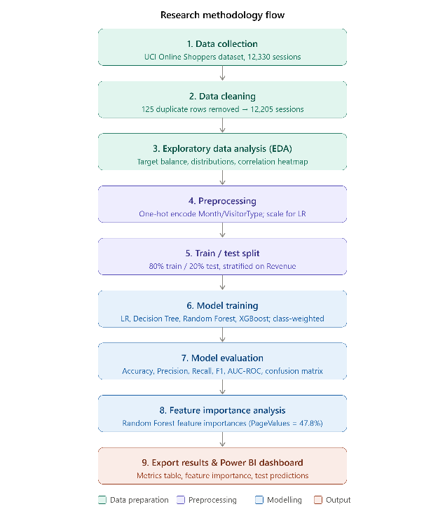
Fig. 1. Research Framework.

Research Design
This study was quantitative, experimental, and comparative [11]. The same data partition was used for training four classification models and were evaluated using identical metrics. This enabled their predictive capabilities to be compared in a consistent and objective manner

Methodological Procedure

1) Literature analysis and model selection
The literature review examined 10 studies related to online purchase-intention prediction. Ensemble models like Random Forest and XG Boost were often found to perform well in prediction tasks [2] - [4], [6]-[8], while Logistic Regression offered a baseline interpretable baseline [8]. Thus, this study involved comparing Logistic Regression, Decision Tree, Random Forest, and XGBoost, by providing an interpretable comparison of established models rather than developing a new algorithm.

2) Data collection and preparation
The Online Shoppers Purchasing Intention Dataset was obtained from the UCI Machine Learning Repository [12]. It contained 12,330 browsing sessions, 17 predictors, and a binary target named Revenue, which was a binary variable representing whether a session led to a purchase.
There were no missing values identified. 12,205 sessions remained after removing 125 duplicate records. The data was transformed into 26 predictor columns, with Boolean variables being converted to binary values while Month and VisitorType being one-hot encoded. OperatingSystems, Browser, Region, and TrafficType retained their integer codes.
Exploratory analysis examined the target distribution and purchase patterns across page engagement, month, visitor type, weekend status, traffic type, and region.

3) Class imbalance and experimental setup
About 15.6% of sessions resulted in purchases, while 84.4% resulting in non-purchases. Class weighting was implemented rather than synthetic oversampling to maintain the original observations, while increasing the penalty for misclassifying purchasers. Hence, balanced class weights were used for Logistic Regression, Decision Tree, and Random Forest, while XGBoost used scale_pos_weight.
Stratified sampling was used to split the data into 80% training and 20% testing subsets, producing 9,764 training sessions and 2,441 testing sessions. A fixed random seed of 42 supported reproducibility. Standardisation was fitted on the training data and applied only to Logistic Regression. The tree-based models were trained on unscaled features.

4) Model implementation
Logistic Regression was used as an interpretable linear baseline with a maximum of 1,000 iterations. Decision Tree used a maximum depth of eight. Random Forest used 300 trees with a maximum depth of 12, while XGBoost used 300 trees, with a maximum depth of six, and a learning rate of 0.1. These parameters were not selected through systematic hyperparameter optimisation, but manually specified.

5) Evaluation and comparison
The models were evaluated on the same held-out test set using accuracy, precision, recall, F1-score, AUC ROC, and confusion matrices. Multiple metrics were required because accuracy alone could be misleading for the imbalanced target. The Random Forest feature importance was also explored to determine influential browsing variables.
The held-out test set was used to evaluate model performance independently, while comparisons with previous studies placed the findings within the existing literature. However, no k-fold cross-validation was performed. The reported metrics are therefore one reproducible data partition rather than average performance across multiple partitions.

Tools and Technologies Used
Data preparation was carried out in Python using Pandas and Numpy, while Matplotlib and Seaborn was used for visualisation, scikit-learn for preprocessing and classification, and XGBoost for gradient boosting. The analysis was organised in Jupyter notebooks within Visual Studio Code. Model metrics, predictions, and feature-importance results were exported for Power BI visualisation.

Challenges and Limitations
Four categorical variables were kept as integer codes, possibly suggesting ordinal relationships that may not be true. A strong correlation between BounceRates and ExitRates, may potentially affect the interpretation of Logistic Regression coefficients. In addition, the models were tested with one train-test split without cross-validation or systematic hyperparameter optimisation.

Summary
The methodology offered a uniform approach for dataset preparation, training four imbalance-aware classifiers, performance comparison, and influential browsing features identification. These procedures supported the objectives of analysing shopper behaviour and predicting online purchase intention.

Results and Discussion

Introduction
This section presents the results obtained from the exploratory data analysis and the four machine-learning classifiers trained on the Online Shoppers Purchasing Intention dataset. Findings are presented through Power BI dashboard visuals and summary tables, followed by a comparative analysis of model performance. These results are then interprets against the five research objectives stated in Section I, addresses the limitations identified in Section IV-L, and evaluates the study's overall contribution.

Exploratory Data Analysis Findings
The dataset contains 12,205 online shopping sessions after removing the duplications. As seen in Section IV-D, there was an imbalance with only 15.63% of sessions (1,908 of 12,205) resulted in a purchase, while 84.37% (10,297 sessions) did not. Figure 2 illustrates this imbalance through a donut chart of the Revenue distribution.
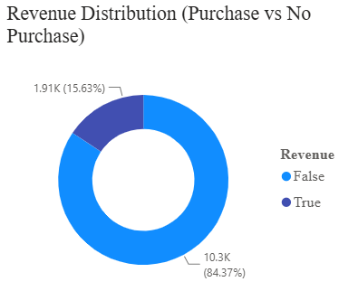
Fig. 2. Revenue Distribution.
This imbalance directly informed the modelling decisions in Section IV-F (class-weighted training) and is also the reason why accuracy alone was not used as a sufficient evaluation metric in this study. It is because a model that predict "no purchase" for every session would still score approximately 84% accuracy without being very useful for identifying buyers.
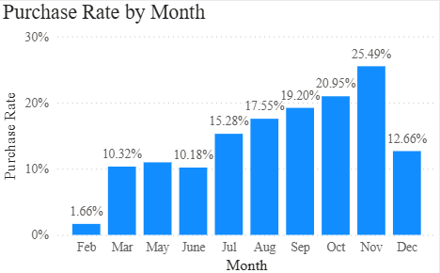
Fig. 3. Purchase Rate by Month.
Figure 3 illustrates purchase rate by month, which began at a low of 1.66% in February and climb to a peak of 25.49% in November, with October (20.95%) also being high. This indicates a pre-holiday shopping activity.
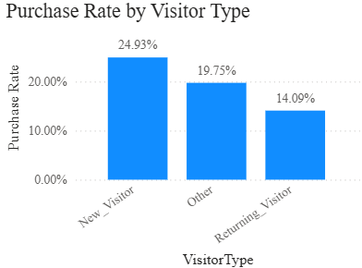
Fig. 4. Purchase Rate by Visitor Type.
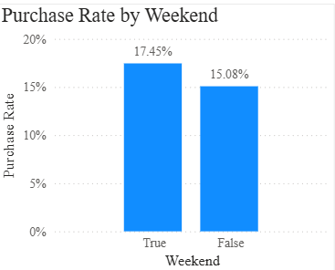
Fig. 5. Purchase Rate by Weekend.
Figures 4 and 5 illustrate purchase rate by visitor type and weekend status. New Visitors converted at a significantly higher rate (24.93%) than Returning Visitors (14.09%). This suggests that return visitors browse more without an immediate purchase intent, while first-time visitors came with a stronger purchase intent in mind. Weekend sessions also showed a slightly higher purchase rate (17.45%) than weekday sessions (15.08%).
These findings directly address Research Objective 1 (analyzing browsing behaviour) and Research Question 1 (which browsing behaviour features are associated with purchase intention), identifying Month, VisitorType, and Weekend as behaviourally meaningful segments even before training a model.

Purchase Driver Analysis
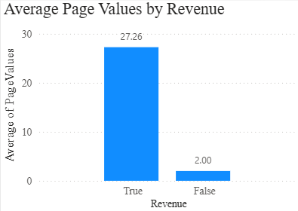
Fig. 6. Average Page Values by Revenue.
Figure 6 illustrates the average Page Values by Revenue outcome. Purchasing sessions had a substantially higher average Page Values (27.26) than non-purchasing sessions (2.00) with a statistical difference exceeding 27 times. In comparison to the other measures, Page Values is the clearest single behavioural signal separating buyers from non-buyers in the dashboard.
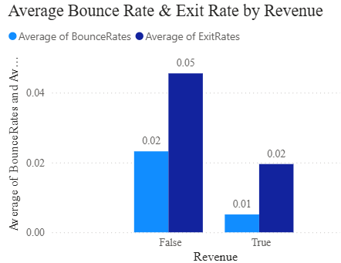
Fig. 7. Average BounceRates and ExitRates by Revenue.
Figure 7 illustrates average BounceRate and ExitRate by Revenue. Non-purchasing sessions showed a higher average BounceRate (0.02 vs 0.01) and ExitRate (0.05 vs 0.02) than purchasing sessions. These results indicate that visitors who disengaged quickly has a lower conversion rate. In Section IV-L, BounceRates and ExitRates were identified as strongly correlated (multicollinearity). Although the both point in the same direction here, they should not be treated as fully independent signals.
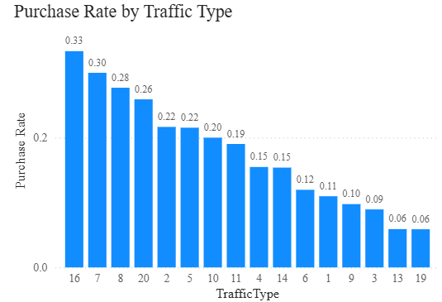
Fig. 8. Purchase Rate by Traffic Type.
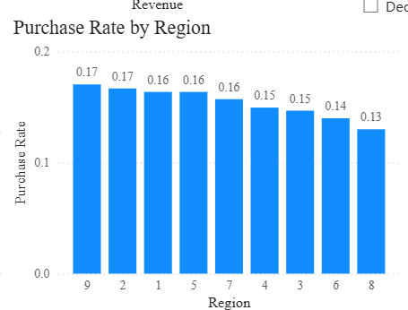
Fig. 9. Purchase Rate by Region.
Figures 8 and 9 illustrate purchase rate by traffic type and region. Purchase rate by Traffic Type ranged from 6% to 33% across the twenty traffic-type codes. However, the highest values came from traffic types with very few sessions and should be interpreted cautiously rather than treated as reliable drivers. Regional differences were comparatively narrow, ranging only between 13% and 17% across the nine regions. This suggests that Region is a weaker predictor of purchase behaviour than page-engagement metrics.

Model Performance Comparison
Table 2 summarizes the performance of the four classifiers on the held-out test set (2,441 sessions), evaluated using accuracy, precision, recall, F1-score, and AUC-ROC, directly addressing Research Objective 3.
TABLE II. Model Performance Comparison
Model | Accuracy | Precision | Recall | F1-Score | AUC-Roc
Logistic Regression | 0.8513 | 0.5164 | 0.7853 | 0.6231 | 0.9110
Decision Tree | 0.8607 | 0.5376 | 0.7853 | 0.6383 | 0.8877
Random Forest | 0.8746 | 0.5709 | 0.8010 | 0.6667 | 0.9316
XGBoost | 0.8873 | 0.6166 | 0.7408 | 0.6730 | 0.9252
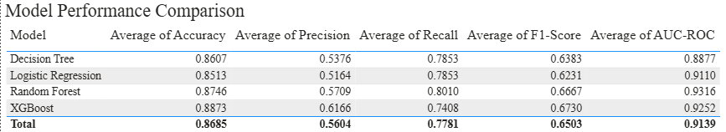
Fig. 10. Model Performance Comparison.
As shown in Table 2 and Figure 10, XGBoost achieved the highest accuracy (88.73%) and F1-score (0.673), indicating the best overall performance in precision and recall among the four models. However, Random Forest had the highest AUC-ROC (0.9316) than XGBoost (0.9252). This indicates that, although XGBoost’s outstanding performance at the standard 0.5 threshold, it discriminates marginally better between purchasing and non-purchasing sessions across all classification thresholds. Logistic Regression, which is the simplest model, still achieved a good AUC-ROC of 0.9110, only slightly behind the ensemble methods. Besides, its recall (0.7853) matched the Decision Tree's. This supports the progression argument outlined in Section IV-H: model complexity did improve performance, but the improvement from Logistic Regression to XGBoost was incremental rather than dramatic, which is a relevant practical consideration given the interpretability trade-off.

Feature Importance
Figure 11 illustrates the feature importance scores derived from the Random Forest model, directly addressing Research Objective 4.
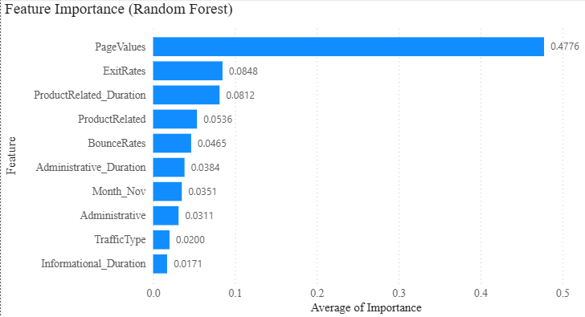
Fig. 11. Feature Importance (Random Forest).
As Figure 11 illustrates, PageValues was the most influential feature with an importance score of 0.4776, more than five times the second-ranked feature, ExitRates (0.0848), followed closely by ProductRelated_Duration (0.0812). This finding is consistent with the EDA results in Section V-C, where PageValues showed the largest gap between purchasing and non-purchasing sessions. This reinforces that on-page engagement value is the key factor in the purchase prediction for this dataset rather than demographic or source-based attributes such as Region or OperatingSystems.

Confusion Matrix Analysis
Figure 12 illustrates the confusion matrix for XGBoost, the best-performing model on accuracy and F1-score, evaluated on the 2,441-session test set.
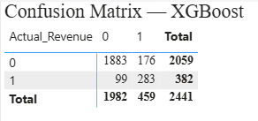
Fig. 12. Confusion Matrix - XGBoost.
As Figure 12 illustrates, the model correctly classified 1,883 true negatives and 283 true positives. Of the remaining sessions, 176 were false positives (predicted purchase, no actual purchase) and 99 were false negatives (predicted no purchase, actual purchase). The relatively higher false positive count reflects the precision–recall trade-off induced by class-weighted training (Section IV-F): weighting the minority class more heavily improves the model's ability to catch actual purchasers (recall of 74.08%) at some cost to precision (61.66%). This is a deliberate trade-off because it usually costs an e-commerce more to miss a real buyer than incorrectly identify a non-buyer as a potential one.

Overall Discussion
Across the exploratory analysis and the four classification models, the results consistently identify page engagement metrics, particularly PageValues, ExitRates, and BounceRates as the strongest indicators of purchase intention. Whereas attributes such as Region and OperatingSystems contributed comparatively little. Among the models tested, XGBoost offered the best balance of predictive performance, though Random Forest remains a close and possibly more robust alternative because of its higher AUC-ROC.
These findings carry practical implications for e-commerce businesses, which marketing and UX teams may benefit more from monitoring and improving on-page engagement signal rather than focusing solely on demographic targeting. For example, they should reduce bounce and exit rates, increase page value through better product recommendations to increase conversion rates.
Several limitations should be acknowledged when interpreting these results. As noted in Section IV-L, OperatingSystems, Browser, Region, and TrafficType were retained as integer-coded categories rather than one-hot encoded. It is because it may have introduced an implicit ordinal assumption that does not reflect reality and could understate their true importance. The identified multicollinearity between BounceRates and ExitRates may also have affected the stability of the Logistic Regression coefficients specifically. Finally, model comparison was based on a single stratified train/test split rather than k-fold cross-validation. This means that the reported metrics represent a single estimate of generalisation performance rather than an average across multiple folds. Thus, the results may vary modestly with a different split.

Critical Evaluation
Revisiting the five research objectives stated in Section 1: Objective 1 (analyzing browsing behaviour) was addressed through the EDA findings illustrated in Figures 2 to 5, which identified clear behavioural differences by month, visitor type, weekend status, and page engagement metrics. Objective 2 (developing classification models) and Objective 3 (comparing model performance) were addressed by training and evaluating four classifiers of increasing complexity, with results summarized in Table 2 and Figure 10. Objective 4 (identifying influential features) was addressed via the Random Forest feature importance analysis illustrated in Figure 11, which clearly identified PageValues as the dominant predictor. Objective 5 (presenting findings through an interactive Power BI dashboard) was fulfilled through the three-page dashboard referenced throughout this section, incorporating slicers for Month, VisitorType, and Weekend to allow interactive exploration of the findings.
Overall, the results confirm that browsing engagement behaviour, rather than demographic or source-based attributes, is the main driver of online purchase intention in this dataset. Besides, the results also show that ensemble-based classifiers (Random Forest, XGBoost) offer a meaningful but not dramatic improvement over a simpler, more interpretable baseline (Logistic Regression). Thus, it is an important practical factor for e-commerce businesses to balance model complexity against interpretability.

Linking to Literature Review
The feature importance results in this study support several findings from the literature review. PageValues appeared as the main predictor. This result is supported by [5], where PageValues showed a strong positive relationship with purchase intent. Besides, research by [9] reported that platform-engagement features were the most reliable predictors of conversion. It also aligns with [10], where dwell time and click behaviour as engagement proxies showed a similar pattern.
For the model comparison results, XGBoost achieved 88.73% accuracy in this study. This is lower than the XGBoost accuracy reported in [2] (90.65%) and [3] (93.54%). Both of these studies used SMOTE to correct class imbalance, while this study used class weighting. Thus, the accuracy gap may come from the difference in imbalance-handling method rather than from the model itself.
For the Random Forest result, it achieved the highest AUC-ROC (0.9316) in this study. This result is consistent with [6] and [7], where Random Forest perform better than the other classifiers tested. In addition, it also matches [5], where Random Forest achieved the strongest result among three simpler models. However, [5] did not apply any imbalance correction, this study did apply class weighting.
Furthermore, Logistic Regression performed reasonably well in this study with an AUC-ROC of 0.9110. Research by [8] supported that Logistic Regression remained a competitive and interpretable baseline. It implies that a simpler model can still perform similarly to more complex ensembles on this type of dataset.
The interpretability approach used in this study followed the guidelines set by [9]. [9] used SHAP values to explain model prediction, while this study used Random Forest feature importance. Both approaches aim to make model decision easier to understand.
In conclusion, this study confirms two major trends from the literature review. First, tree-based and ensemble methods perform strongly on this type of behavioural data. Second, page-engagement features are more important than demographic or source-based features. This study extends the reviewed literature by combining both trends together. It compares four models directly and pairs the results with an interactive Power BI dashboard. This addresses the research gap identifies earlier, which is most reviewed studies focus on either performance or interpretability, but rarely both at once.

Conclusion of Results and Discussion
This study analyzed 12,205 online shopping sessions and compared four machine-learning classifiers for predicting purchase intention. The results show that page engagement metrics, especially PageValues, are the dominant predictors of purchase behaviour. Moreover, XGBoost and Random Forest offer the strongest predictive performance among the models tested, each with a slightly different strength (accuracy/F1 versus AUC-ROC respectively). These findings are visualized through an interactive Power BI dashboard, which provide e-commerce businesses with actionable insight into which browsing behaviours are most associated with conversion, directly fulfilling the objectives and addressing the research questions set out at the start of this study.

Conclusion and Future Work
This study examined the application of machine-learning classification methods to predict whether an online shopping session would result in a purchase. Using the Online Shoppers Purchasing Intention Dataset, 125 duplicate records were removed, resulting in 12,205 sessions for analysis. The exploratory data analysis revealed that there were significant differences between purchase behaviour for various browsing-related features. Specifically, PageValues was identified as the strongest indicator of purchase intention, while BounceRates and ExitRates were also associated with differences between purchasing and non-purchasing sessions.
Four classification models were developed and compared: Logistic Regression, Decision Tree, Random Forest and XGBoost. XGBoost achieved the highest accuracy of 88.73% and the highest F1-score of 0.6730, while Random Forest achieved the highest AUC-ROC of 0.9316 and the highest recall of 0.8010. Therefore, XGBoost gave the best overall accuracy at the chosen classification threshold, while Random Forest was a good alternative when the goal was to classify a higher percentage of actual buyers and overall classification accuracy. There findings are generally consistent with previous studies that showed that tree-based and ensemble models performed well in predicting online purchase-intention [2], [3], [7].
The study achieved its objectives by analysing the browsing behaviour, creating and comparing various classifications models, exploring influential features, and visualizing the results using Power BI. The results provide practical value for e-commerce businesses by showing that engagement-related behaviours may be more useful for predicting purchase intention than attributes such as Region or OperatingSystem. These insights can help with more effective customer targeting, website optimisation and decision making for conversion.
However, several limitations remain. Some categorical variables were retained as integer codes rather than one-hot encoded, BounceRates and ExitRates showed multicollinearity, and model performance was tested using only one train test split instead of k-fold cross-validation. In addition, only one publicly available dataset was used.
Future research could therefore apply k-fold cross-validation, improve categorical-variable encoding, compare class weighting with methods such as SMOTE or bootstrapping, and test the models on other e-commerce datasets. Further explainability techniques, such as SHAP could also be explored to provide deeper understanding of individual model predictions. Overall, this study demonstrates that combining machine learning with web analytics and visualisation can provide useful predictive and behavioural insights for understanding online shopper purchase intention.

REFERENCES
- C. O. Sakar, S. O. Polat, M. Katircioglu, and Y. Kastro, "Real-time prediction of online shoppers' purchasing intention using multilayer perceptron and LSTM recurrent neural networks," Neural Computing and Applications, vol. 31, no. 10, pp. 6893–6908, 2019.
- Abdullah-Al-Tanvir, I. A. Khandokar, A. K. M. M. Islam, S. Islam, and S. Shatabda, "A gradient boosting classifier for purchase intention prediction of online shoppers," Heliyon, vol. 9, no. 4, Art. e15163, 2023.
- J. Adhikari, "Online Shoppers' Purchase Intention using Ensemble Learning Approach," International Journal of Next-Generation Computing, vol. 14, no. 4, 2023.
- A. Arora, Sakshi, and U. Gupta, "Ensemble Learning for Enhanced Prediction of Online Shoppers' Intention on Oversampling-Based Reconstructed Data," in International Conference on Innovative Computing and Communications (ICICC 2023), Lecture Notes in Networks and Systems, vol. 731, Singapore: Springer, 2024, pp. 741–752.
- X. Shi, "The Application of Machine Learning in Online Purchasing Intention Prediction," in Proc. 6th International Conference on Big Data and Computing (ICBDC 2021), Shenzhen, China, 2021, pp. 21–29.
- A. Irsheid, A. Abdallah, M. Qasaimeh, Z. Zaza, and M. Qasaimeh, "Predicting User Purchase Intention in Web Analytics Using Machine Learning with Bootstrapping," in 2025 16th International Conference on Information and Communication Systems (ICICS), Irbid, Jordan, 2025, pp. 1–6.
- K. Baati and M. Mohsil, "Real-Time Prediction of Online Shoppers' Purchasing Intention Using Random Forest," in Artificial Intelligence Applications and Innovations (AIAI 2020), IFIP Advances in Information and Communication Technology, vol. 583, Springer, Cham, 2020, pp. 43–55.
- M. Muda, R. Iswari, and M. Ahsan, "Prediction of Online Shopper's Purchasing Intention Using Binary Logistic Regression, Decision Tree, and Random Forest," in Artificial Intelligence Applications and Innovations (AIAI 2020), IFIP Advances in Information and Communication Technology, vol. 583, Springer, Cham, 2020.
- J. A. Bastos and M. I. Bernardes, "Understanding Online Purchases with Explainable Machine Learning," Information, vol. 15, no. 10, Art. 587, 2024.
- X. Niu, C. Li, and X. Yu, "Predictive Analytics of E-Commerce Search Behavior for Conversion," in Proc. 23rd Americas Conference on Information Systems (AMCIS 2017), 2017.
- J. W. Creswell and J. D. Creswell, Research design: Qualitative, Quantitative, and Mixed Methods Approaches. Sage Publications, Incorporated, 2022.
- C. Sakar and Y. Kastro, “Online Shoppers Purchasing Intention Dataset,” UCI Machine Learning Repository, 2018, doi: 10.24432/C5F88Q.

